**1. Introduction**

Markbot facilitates marketing campaigns of startups and businesses by collecting the company’s bio from the user and smartly finding out potential customers of the service/product which the company is offering.

Markbot is an Artificial Intelligence-powered marketing and branding tool. Along with target market identification, it generates visual and textual content for social media campaigns. The content generated is tailored as per the likes of the target audience. This ensures an effective marketing campaign.

**2. Competitor Analysis (Development Based Project)**

Sentence:

Wix.com [1] offers us an efficient logo maker tool along with a website generator. However, it lacks the poster generator so it doesn’t serve to be an all in one project.

Canva and Adobe Spark Post are great poster designing tools but they have a limited number of templates and such features to keep the design consistent. Although very user-friendly but brand uniqueness is hard to achieve.

We have Adobe Photoshop, Adobe Illustrator and GNU Image Manipulation Program which are designed to give the user extreme control and flexibility. But all that comes at the price of a huge learning curve.

**3. Project Vision**

The vision behind MarkBot is to provide a platform that offers AI-powered marketing and branding to businesses and startups in order to boost up business growth and sales.

**3.1 Problem Statement**

In the modern world, every business and startup needs a social media presence where it can effectively engage with its potential customers, build relationships, create a brand image and boost sales. For this, they have to run marketing campaigns from time to time and figure out appropriate branding styles for their businesses.

A big segment of businesses exists with little or no marketing expertise, especially the new startups, wanting to reach their customers. This job of running marketing campaigns and finding out potential customers is currently being done by hiring multiple experts like market analysts, copywriters, graphic designers and social media managers. No tool as of right now exists which automates the process of marketing and branding.

Relying and spending on hit and trial methods:

A vast amount of money is spent on running campaigns on social media from time to time in a hit and trial manner to discover potential customers and a lot of work and effort is put into it and many people are hired for it. This leads to avoidance by small scale startups because of their lean budget and as a result, they are not able to reach their customers.

**3.2 Business Opportunity**

Today almost every business acquires a social media presence and they need good marketing and branding for their businesses on social media to flourish and for that, they require to identify their target market and audience so that they can craft their marketing content like posts, ads , posters, logos etc accordingly in most effective way. MarkBot aims to bridge this gap of nonawareness of technicalities regarding marketing by providing a tool that automates the process of marketing and branding.

This application is in the business domain which covers a huge market and as of right now no such tool exists so it can become a lucrative opportunity by becoming the first mover in the market.

**3.3 Objectives**

We intend to:

* Ease the process of marketing and branding.
* To find the target audience for the businesses with the help of AI.
* To put an end to hit and trial methods of running campaigns and finding customers.
* Generate marketing and branding content like posters, logos, marketing copy, and ad optimization.

**3.4 Project Scope**

**Stakeholders:** Businesses of all sizes, social media marketers.

**Requirements:** Locating potiential customers, producing appropriate branding, generating logo according to branding and posters according to logo. Also the generation of written content.

**Scope:** The business industries we’re targetting are food and travel. We’re limiting the content generation to branding and some part of marketing (marketing copy and poster generation).

**Process:** The company provides us with its Bio i.e Business industry, Sub-Industry and Location

**3.5 Constraints**

**Business Constraints**:

**Computer Science Constraints:**

Locating or generating a dataset sufficient enough for training of our machine learning model.

**3.6 Stakeholders Description**

**3.6.1 Stakeholders Summary**

Stakeholders of Markbot are as follows:

* CEOs of all kinds of businesses and startups
* Marketer

**3.6.2 Key High-level goals and Problems of Stakeholders**

|  |  |  |
| --- | --- | --- |
| **Stakeholders** | **Goals** | **Problems** |
| CEO | Need to increase sales and profits and also create a brand image | Complicated and long process |
| Marketer | Run an effective marketing campaign, find target market and create brand image. | Hit and trial method used to evaluate marketing campaigns and finding out customers. |

**4. Software Requirement Specifications**

**4.1 List of Features**

Following are the features that cover the whole project of MARKBOT :

1. Web application to enter business details.
2. Target market identification for the given business.
3. Branding (Fonts, Colours and theme) suggestion according to Target Market.
4. Marketing content including the posters and written content.
5. Ad optimization suggestions using target audience.

**4.2 Functional Requirements**

1. System should provide login functionality and it should keep the data of a user safe.
2. There should be some flexibility in designs e.g colors should be modifiable.
3. User must be able to change the font style.
4. User must be able to change the Icon style from the given icons.
5. User must be able to change the poster style from the given poster templates.
6. The content generated should be easily downloadable in an appropriate form (png, jpeg etc).
7. There should be an option to print the content.
8. It should allow user to share directly to social media platforms.

**4.3 Quality Attributes**

|  |  |
| --- | --- |
| **Attribute** | **Description** |
| Usability | System will provide easy to use user interface for user to understand the system and effectively use the system. |
| Performance | System will be consistent and fast enough to generate content for marketing and branding. |
| Reliability | Chances of system failure should be low. Accurate content must be generated. |
| Security | System will provide security against unauthorized access and it should keep the data of a user safe. |
| Availability | System should be accessible and live all the time. |
| Scalability | System will be easy to scale as per need. |
| Fault Tolerance | System should be resilient and tolerant enough towards errors and faults. |

**4.4 Non-Functional Requirements**

1. A non-technical person should be able to enter the business details easily.
2. The target audience should be displayed in a way that is understandable to a non-marketing person.
3. Good human-computer interface for the website application.
4. System should be responsive with minimal response time.
5. System should be live all the time.
6. System must be secure in providing authorized access only to users with valid credentials.
7. System must be reliable enough.
8. System must be scalable according to needs.

**5. High level Use Cases**

|  |  |
| --- | --- |
| **Use case** | Login |
| **Actor** | User |
| **Type** | Primary |
| **Description** | All users are required to provide credentials to authenticate their id before system access. |

|  |  |
| --- | --- |
| **Use case** | View Content |
| **Actor** | User |
| **Type** | Primary |
| **Description** | The user views all the content generated from his account. |

|  |  |
| --- | --- |
| **Use case** | Enter Business Bio |
| **Actor** | User |
| **Type** | Primary |
| **Description** | The user needs to enter business bio through a form by selecting appropriate industry, sub-industry, name and location of the company. |

|  |  |
| --- | --- |
| **Use case** | Download Content |
| **Actor** | User |
| **Type** | Primary |
| **Description** | Choose which content you need to download. |

|  |  |
| --- | --- |
| **Use case** | Modify Content |
| **Actor** | User |
| **Type** | Primary |
| **Description** | Choose which content you need to modify. e.g(Delete/Make New logo) |

**5.1 Use case diagram:**

**6. Iteration Plan:**

MARKBOT has been divided into five iterations considering the nature of the work and familiarity with the tools. The Five iterations are as follows:

**Iteration 1:**

MARKBOT architecture designing, project poster making, and dataset selection.

**Iteration 2:**

Branding: Logo generation , and machine learning model selection.

**Iteration 3:**

Marketing: Poster generation, data gathering, and model training.

**Iteration 4:**

Integration of all modules with model.

**Iteration 5:**

Overall final testing of system linked with all modules (testing will be done throughout all iterations)

**7. Iteration 1:**

Iteration 1 is all about designing the architecture of our system which involves Object-oriented design. Architecture must portray the whole system, it's inputs, processing, and outputs with clear understanding. Furthermore, iteration 1 involves dataset selection for our machine learning model.

**7.1 Expanded Use Cases:**

**UC01:** Enter Business Bio

**Scope:** MARKBOT

**Level:** User Goal

**Primary Actor:** User

**Pre-Conditions:** User must be logged in

**Success Guarantee:** User successfully enters bio

**Main Success Scenario:**

|  |  |
| --- | --- |
| **Actor Action** | **System Response** |
| 1.User logs into MARKBOT |  |
|  | 2. System displays the homepage and business industries list. |
| 3. User selects business industry |  |
|  | 4. System displays sub-industries list of that business. |
| 5. User selects sub-industry |  |
|  | 6. Selection completed |

**Extensions:** Maybe some users enter incorrect bio.

**Special Requirements:** scrollable list.

**Technology and Data Variation List:** list view

**UC02:** Select Content G

**Scope:** MARKBOT

**Level:** User Goal

**Primary Actor:** User

**Pre-Conditions:** User must be logged in and bio entered

**Success Guarantee:** User makes a selection successfully

**Main Success Scenario:**

|  |  |
| --- | --- |
| **Actor Action** | **System Response** |
| 1.User logs into MARKBOT |  |
|  | 2. System displays homepage and asks for bio input |
| 3. User enters business bio |  |
|  | 4. Bio captured successfully alert |
|  | 5. System asks for selection of content which user wants to generate |
| 6. User makes selection |  |
|  | 7. Selection made successfully |

**Extensions:** Maybe selection which the user wants to make is not offered by the system.

**Special Requirements:** A clean view showing types of selections.

**Technology and Data Variation List:** drop-down list.

**UC03:** View Content

**Scope:** MARKBOT

**Level:** User Goal

**Primary Actor:** User

**Pre-Conditions:** User must be logged in

**Success Guarantee:** User is able to view content

**Main Success Scenario:**

|  |  |
| --- | --- |
| **Actor Action** | **System Response** |
| 1. User logs into MARKBOT |  |
|  | 2. System displays homepage |
| 3. User clicks on view content |  |
|  | 4. Takes to new screen of user content |
| 5. User successfully views all his content |  |
|  |  |
|  |  |

**Extensions:** Maybe some content might not load.

**Special Requirements:** Display all content in clear fashion with some type of view ( date modified, size etc).

**Technology and Data Variation List:** Web page and thumbnail list view.

**UC04:** Download Content

**Scope:** MARKBOT

**Level:** User Goal

**Primary Actor:** User

**Pre-Conditions:** User must be logged in

**Success Guarantee:** User is able to download content

**Main Success Scenario:**

|  |  |
| --- | --- |
| **Actor Action** | **System Response** |
| 1.User logs into MARKBOT |  |
|  | 2. System displays homepage |
| 3. User clicks on view content |  |
|  | 4. Takes to new screen of user content |
| 5. User clicks on content to download |  |
|  | 6. File downloads successfully |
|  |  |

**Extensions:** Downloading error while downloading

**Special Requirements:** One-click downloadable files.

**Technology and Data Variation List:** Web page

**UC05:** Log In

**Scope:** MARKBOT

**Level:** Security Goal

**Primary Actor:** User

**Pre-Conditions:** System must be on

**Success Guarantee:** Log into system

**Main Success Scenario:**

|  |  |
| --- | --- |
| **Actor Action** | **System Response** |
| 1. User launches MARKBOT |  |
|  | 2. System displays login screen |
| 3. User enters credentials |  |
|  | 4. System logs in |

**Extensions:** Maybe some users cannot log in due to incorrect credentials.

**Special Requirements:** Log in dialogue should be clear and user-friendly.

**Technology and Data Variation List:** Web page

**UC04:** Modify Content

**Scope:** MARKBOT

**Level:** User Goal

**Primary Actor:** User

**Pre-Conditions:** Some content is already generated by the user.

**Success Guarantee:** User is able to modify content.

**Main Success Scenario:**

|  |  |
| --- | --- |
| **Actor Action** | **System Response** |
| 1.User logs into MARKBOT |  |
|  | 2. System displays homepage |
| 3. User clicks on view content |  |
|  | 4. Takes to new screen of user content |
| 5. User clicks on content to modify |  |
|  | 6. System displays list of modifications.(ADD, DELETE) |
| 7. User makes selection |  |
|  | 8. Change is updated |

**Extensions:** Change is not reflected in preview.

**Special Requirements:** One-click modifications.

**Technology and Data Variation List:** list view of modifications.

**7.2 Activity Diagram**

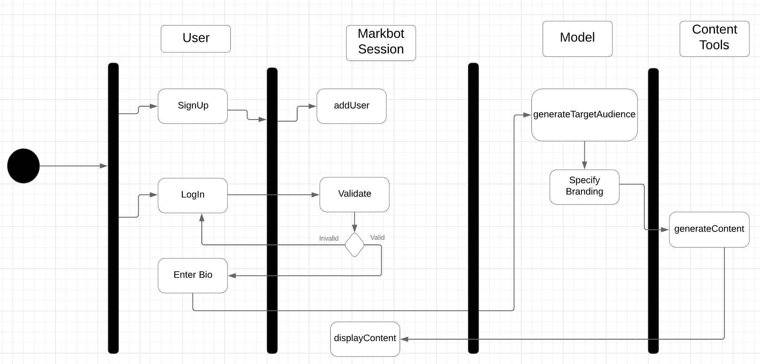

**7.3 Domain Model**

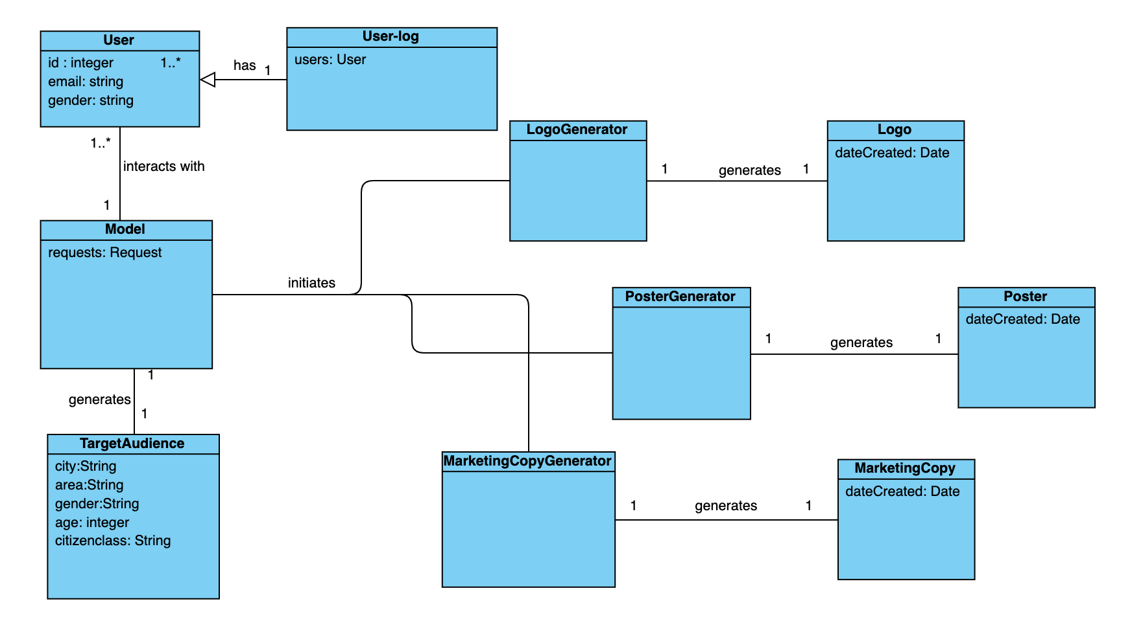

**7.4 System Sequence Diagram**

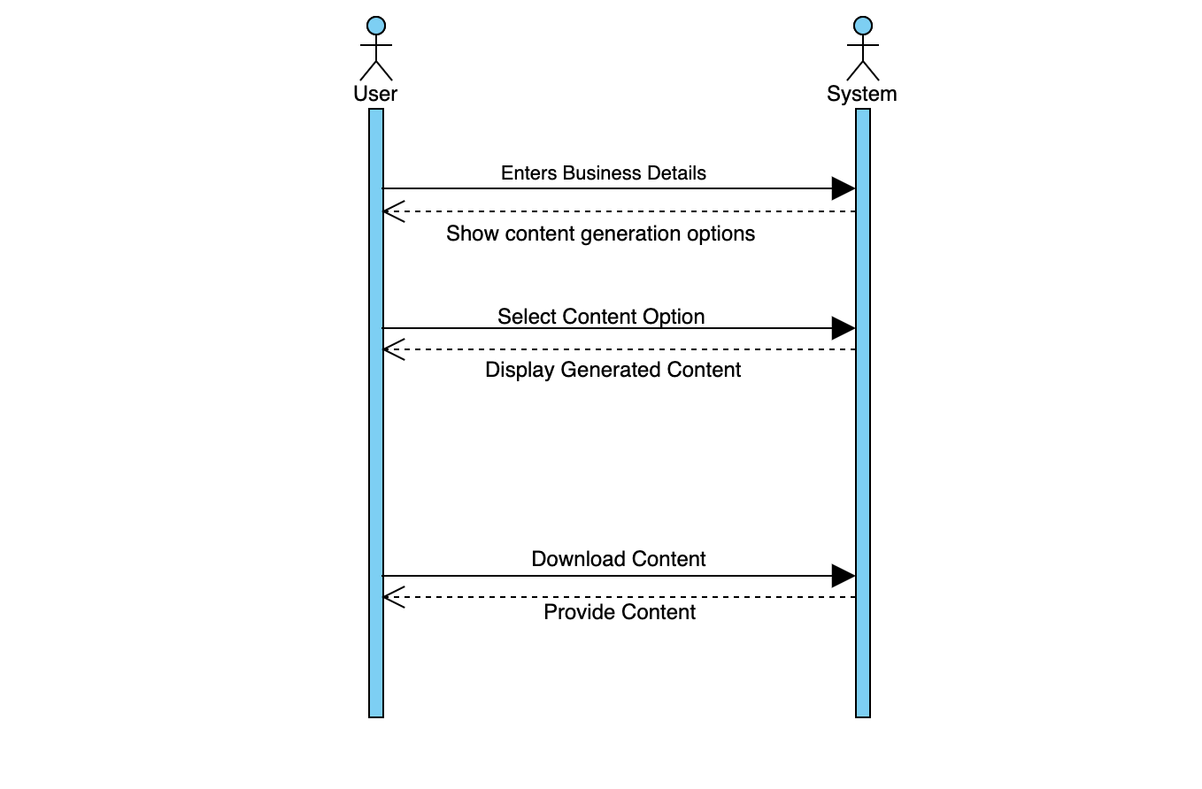

**7.5 Operation Contracts**

**Name**: login(input)

**Responsibility**: Logs in users of the system

**Type**: System.

**Cross Reference**: Log in

**Pre-Conditions**: System must be on.

**Post-Conditions**: New instance was instantiated by the user.

**Name**: BusinessBio_Entry(CompanyName, Industry, SubIndustry, Location)

**Responsibility**: Feeds in the company information to the neural network.

**Type**: System.

**Cross Reference**: Enter Business Bio

**Pre-Conditions**: User is logged into the system.

**Post-Conditions**: The Company’s Name, Industry, Sub-Industry and location is fed into the neural network system.

**Name**: Generate_Content(target_audience)

**Responsibility**: Generates Branding , Logo , Posters and marketing copy as per target audience.

**Type**: System.

**Cross Reference**: View Content, Select Content, Download Content

**Pre-Conditions**: User is logged into the system business bio is entered correctly.

**Post-Conditions**:All the content is generated as per the target audience. It has a preview option and is also downloadable..

**7.6 Sequence Diagrams**

**7.7 Class Diagram**

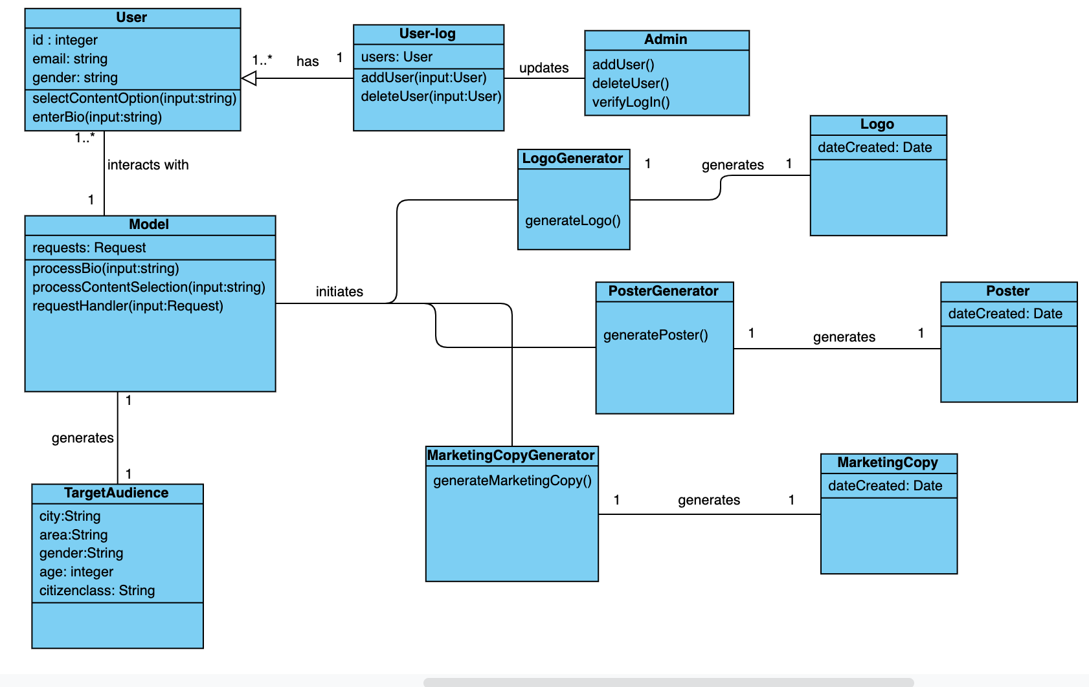

**7.8 Architecture Diagram**

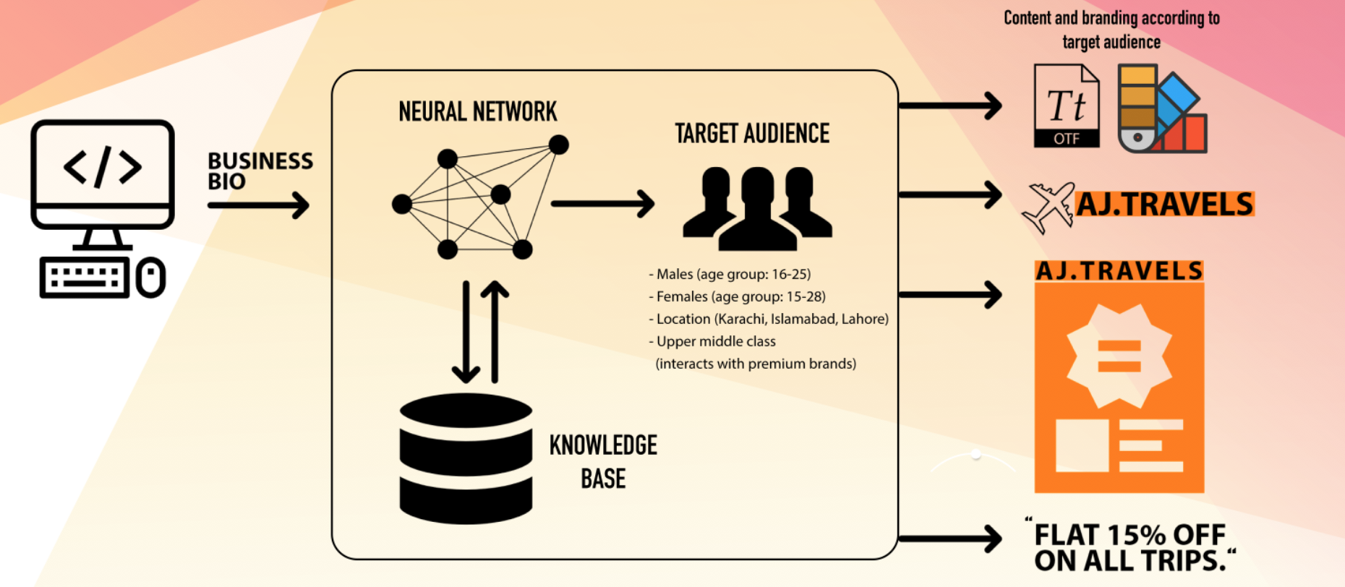

**References:**

**[1]** [**www.wix.com**](http://www.wix.com)